# Project Title: Recipe Finder

## Team Members:

* Sally Beckwith
* Ben Leone
* Keanu Korkor
* Herbie Molina

## Problem:

A person comes home after a long day or work and can’t decide what to have for dinner. Eating out gets expensive and unhealthy. This app will help the user to discover what they can make with items they already have in their kitchen.

## Project Description:

Find recipes based on foods available in your home. Enter a list of food items to include in the recipe search and the number of recipes to find. App will return recipes that meet the criteria and display them.

## Sketch:

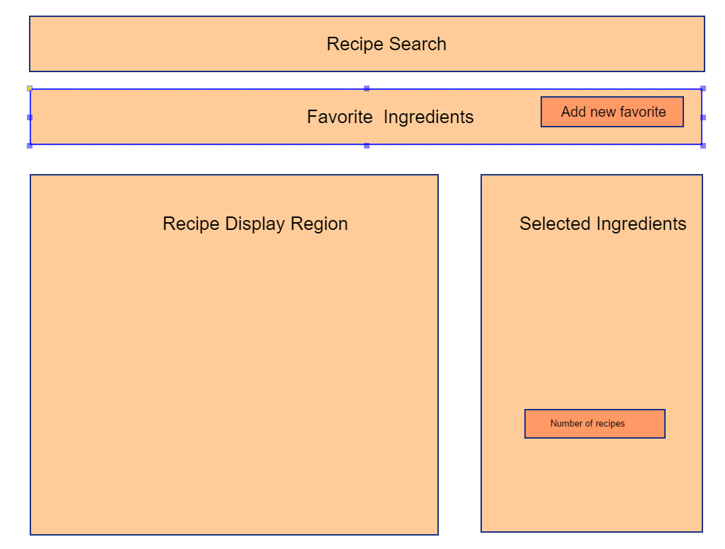

## APIs to be used:

Spoonacular

## Tasks:

Layout html

Get api calls going